EC5070: Database Systems Lab 04

WIMALASOORIYA G.H.N.P.D

2022/E/039

06.06.2025

**Attach the below screenshots for following scenarios.**

Q1. Database with your registration number and lab number.

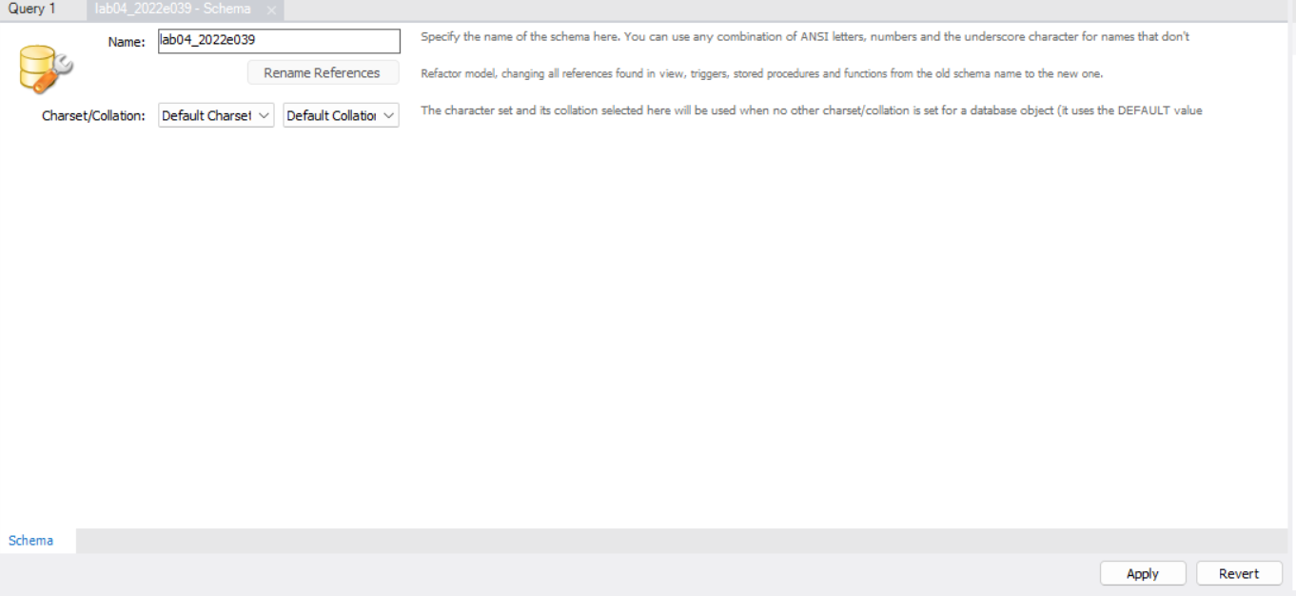

Q2. Tables with the name sample population and population.

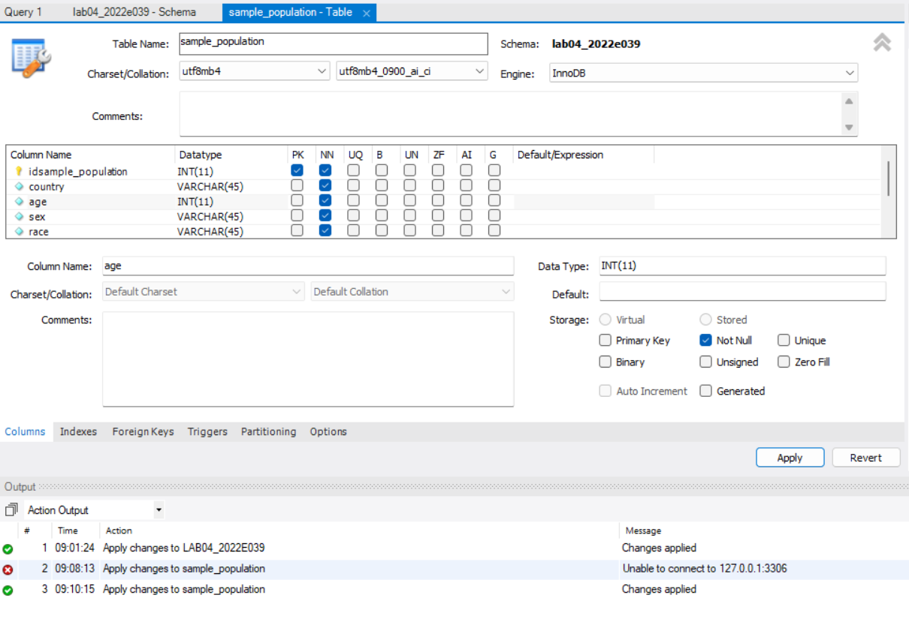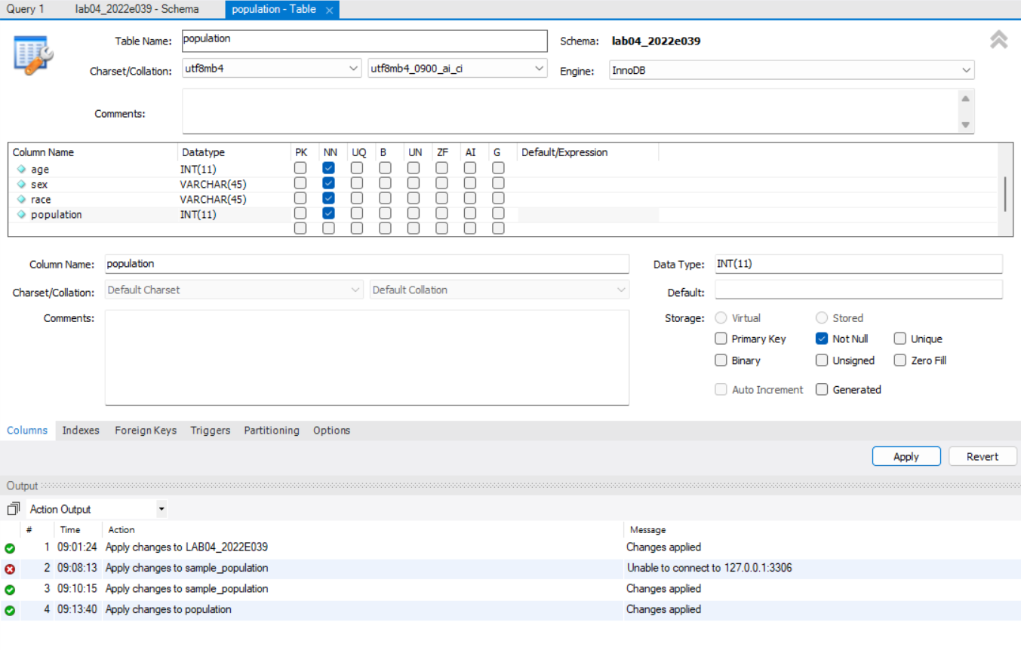

Q3. Importing .csv files using import data wizard.

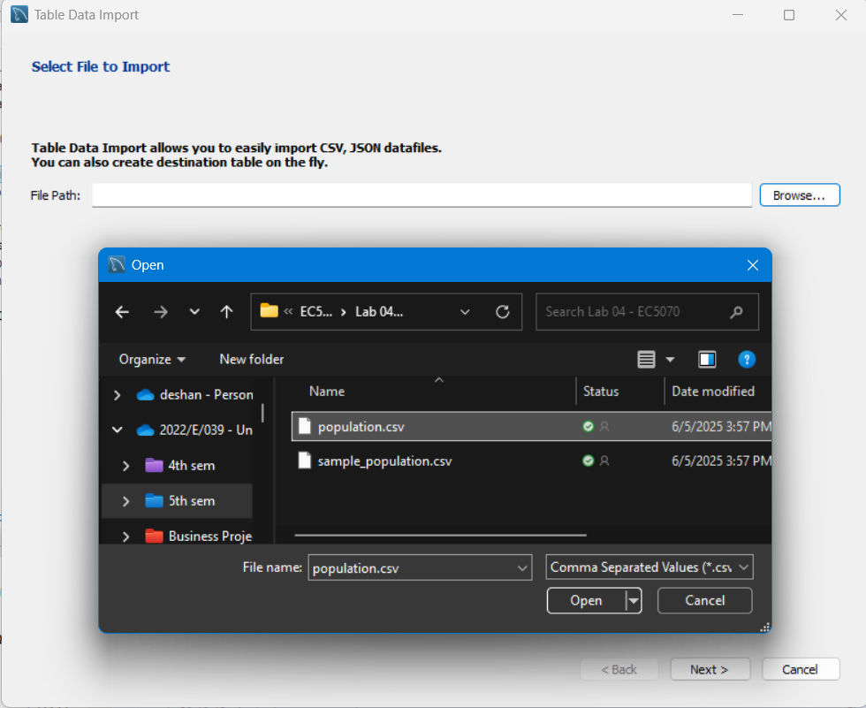

Q4. Importing .csv files using queries

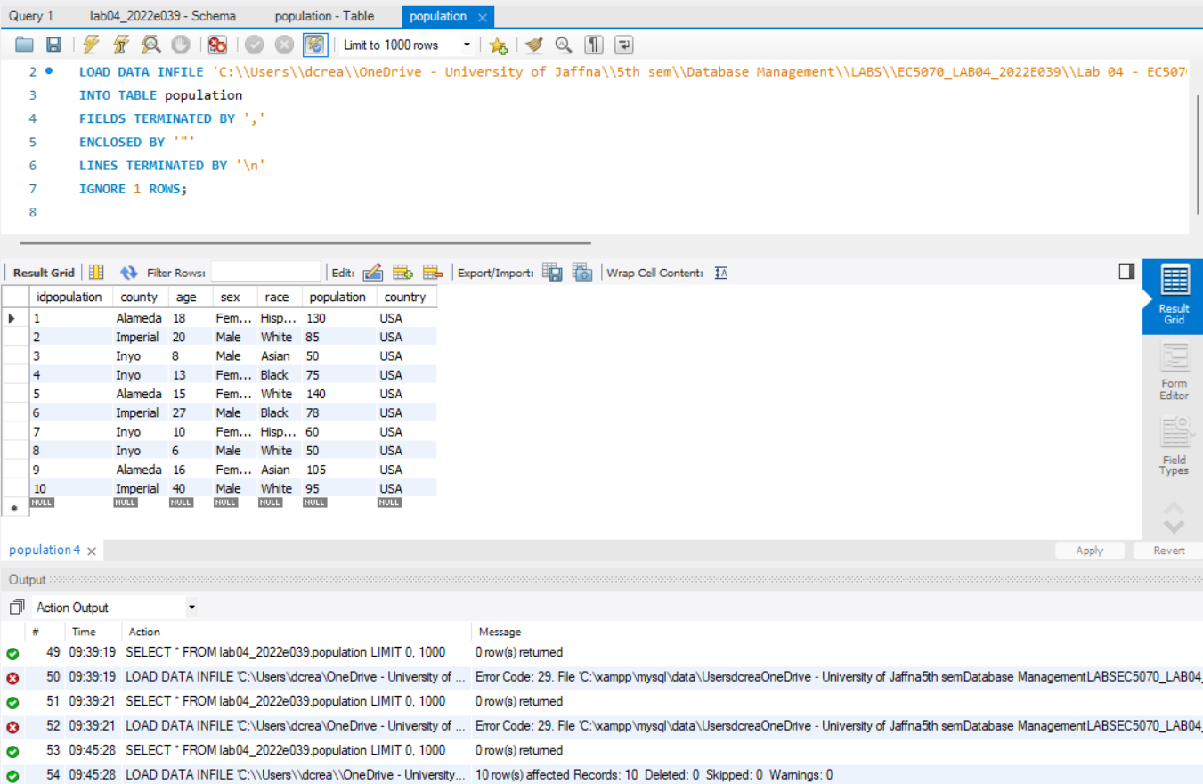

Q5. Explanation of your observation for question 3,4.

**GUI Import (Table Data Import Wizard):**

* User-friendly and simple for beginners.
* Allows column mapping and previews.
* Slower for large files or bulk data.

**Import (**LOAD DATA INFILE**):**

* Much faster, especially for large datasets.
* More flexible and scriptable.
* Requires correct file path and column alignment.
* Needs enabling of LOCAL_INFILE and correct permissions.
* Doesn't handle malformed data gracefully errors may stop the import.

Q6. Attach the screen shots for each queries given in question 6.

**CODE**

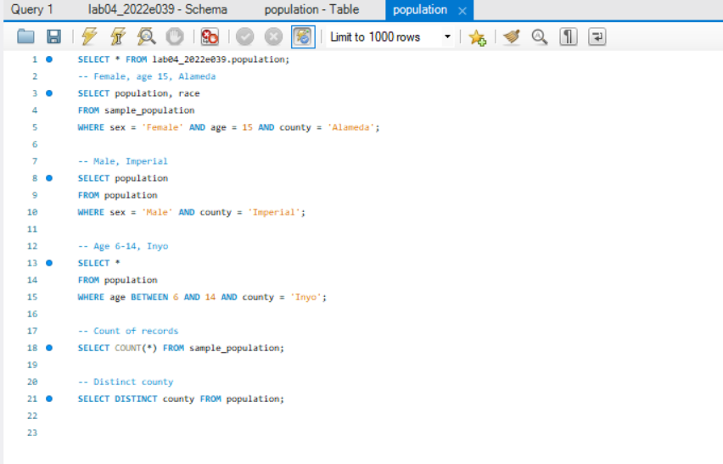

**EXECUTION TIME**

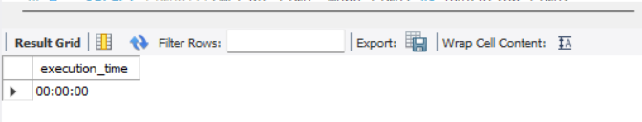

**FOR SAMPLE TABLE**

6.1

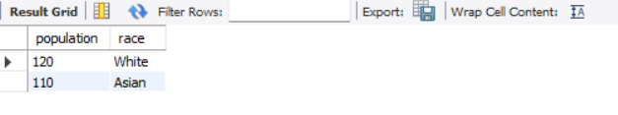

6.2

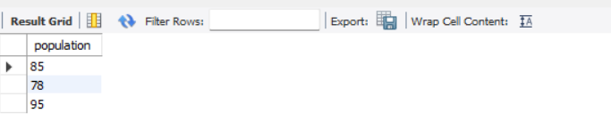

6.3

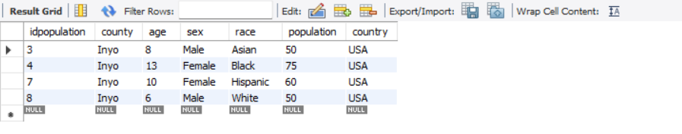

6.4



6.5

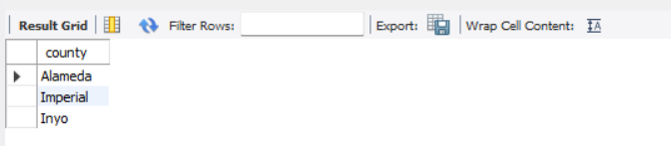

**EXECUTION TIME**

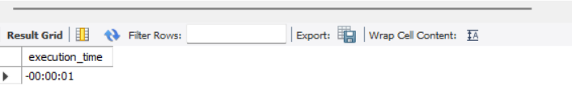

**FOR SAMPLE_POPULATION TABLE**

6.1

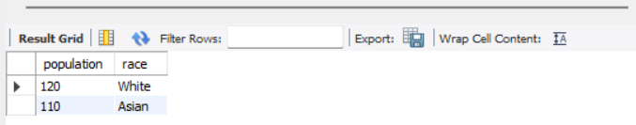

6.2

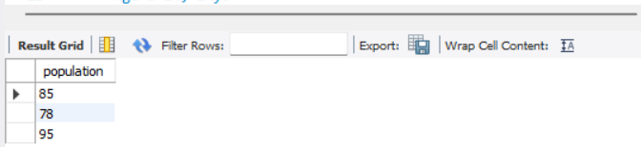

6.3

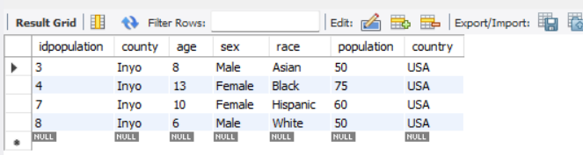

6.4

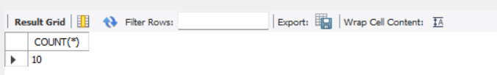

6.5



Q7. Screenshot for create the primary key for two tables and the listed queries in question 4.

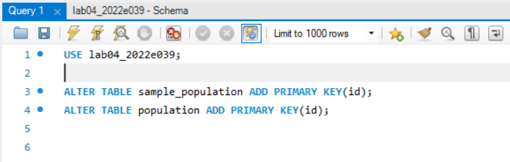

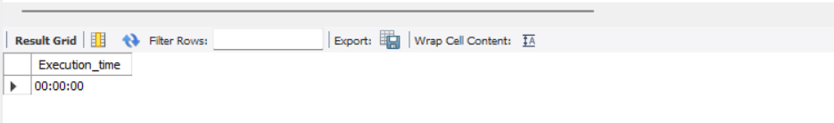

Q8. Screenshot for create the secondary index for these two tables and do the queries again (in question 4) and the time duration.

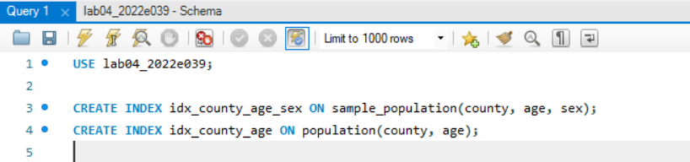

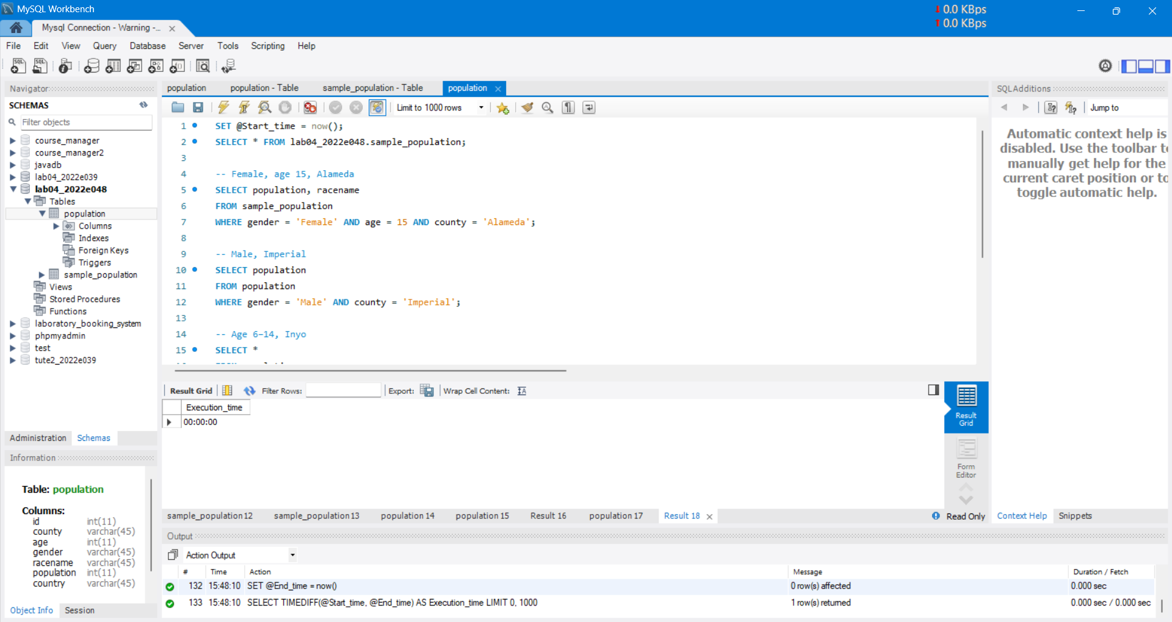

Q9. Explanation for question 4,5,6.

* + - **Speed Differences:**
* **Before Indexing:**

Queries were slower, especially those using WHERE conditions on large text fields (county, sex, race).

Full table scans occurred for every query.

* **After Adding Primary Key:**

Minor improvement observed, mostly affecting queries that involved id-based lookups.

Queries not using the primary key column showed no significant speed-up.

* **After Adding Secondary Index:**

Significant speed improvement for queries filtering by county, age, sex.

Indexes on multiple fields (e.g., county, age, sex) reduced query time dramatically by narrowing the search.